


TEAM KENT VENSDAY

MASCOT

Recruitment Pack



Welcome From The CEO
Thank you for your interest in the position of Team Kent Vensday Mascot, at Kent Student’s Union (KSU), and considering us as your new employer.
This is an exciting opportunity to join a team that sits at the heart of our organisation, supporting both KSU and Kent Union Trading Ltd (KUTL), our commercial services. From digital platforms used by
thousands of students to the technology that underpins our venues, events and outlets, this role plays a key part in delivering the services and experiences that define student life at Kent.
Students are the reason Kent Students’ Union exists. We are there through their university journey. Our amazing staff and volunteers work towards improving their experience and you will be joining a talented and committed team.
Thank you for your interest in the role, this pack should provide everything you need to support your application. However, for more information or for an informal chat about the role you can contact us at kentunionrecruitment@kent.ac.uk.
We look forward to hearing from you.
Mel Sharman Chief Executive

About Us
OUR VISION
Where we’re going
Our vision is to provide the best student experiences on the planet
OUR BELIEFS
Why we do it
We believe every student should have the opportunity to try out new experiences, have fun, make new friends and be part of a
community; we believe every student should have the opportunity to fulfil their potential in life, have a voice in society and make a difference.
OUR VALUES
How we’re perceived Bold
- We are brave and courageous; we stand up for students’ rights
- We are innovative
- We challenge the status quo
Inclusive
- We welcome all people and appreciate their uniqueness
- We are champions of equality and diversity
Supportive
- We look out for people
- We want students to succeed in life so we offer transformative experiences for them to get involved in
- We ensure our staff have a healthy work-life balance

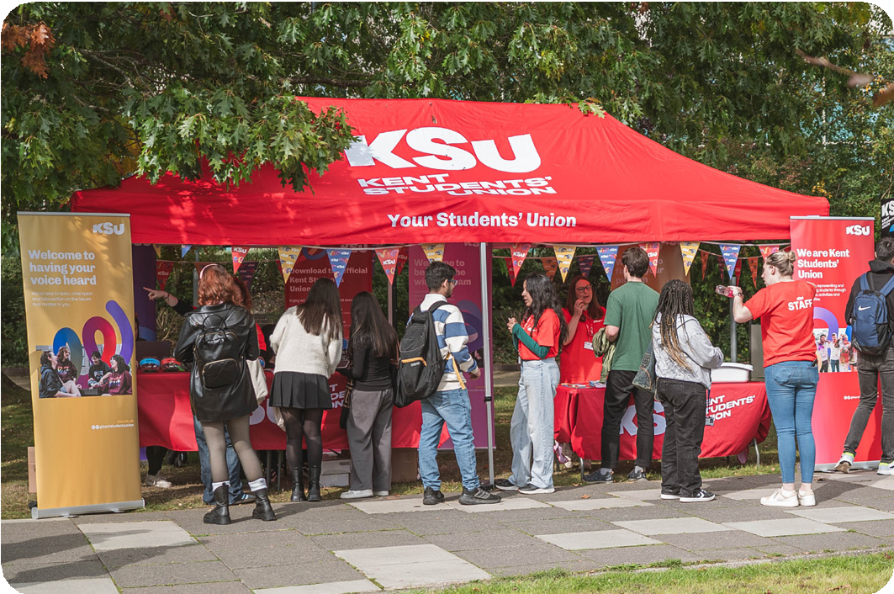
OUR MISSION
Why we’re here
We are a charity that supports students at the University of Kent.
We are:
- Student led
- Here for our members
- A place of opportunities

Find out more at www.ksu.co.uk/strategy

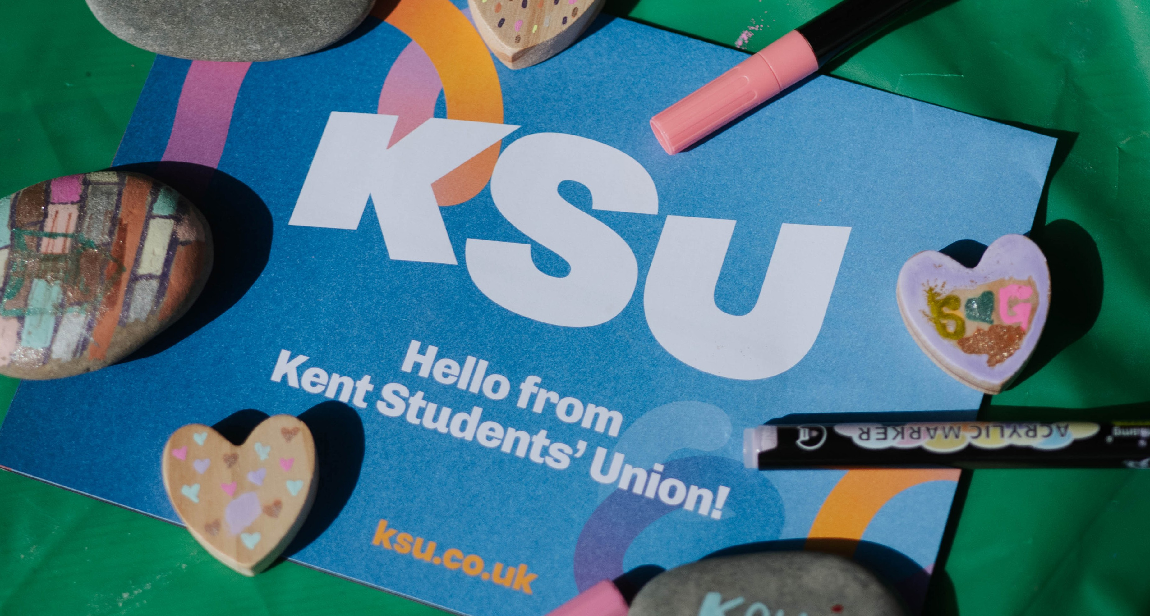
How We Are Run

How Are We Financed?
We have two income streams: University core grant funding and generating income through KUTL, our commercial services trading company. Our KUTL profits are gift aided into the Kent Student’s Union charity and reinvested back to provide essential services and activities for our students and members.

Our Trustee Board
As a registered charity, we are governed by a Board of Trustees. It is made up of the 3 elected Full-Time officers, 4 External Trustees and 4 Student Trustees. Our Board of Trustees has ultimate responsibility for directing the affairs of Kent Student’s Union, ensuring we are solvent, well-run and delivering our objectives. The day to day running of the Union and KUTL is delegated to the Chief Executive, Senior Management and staff team.

KUTL Board
Kent Union Trading Limited (KUTL) Board of Directors has ultimate responsibility for directing the affairs of Kent Union Trading Limited, ensuring it is solvent, well-run and delivering its objects.
KUTL is a wholly owned subsidiary of Kent Student’s Union, which exists to run activities on behalf of Kent Student’s Union that are outside the scope
of Kent Student’s Union’s charitable purpose. The Board is made up the External Chair, President, 3 Trustees and the Executive Directors which include the Chief Executive and Director of Commercial Services.

Staff And Management Structure
Kent Student’s Union employs approximately 411 staff to provide services for its members. Staff are of two types: approximately 300 student staff, who work whilst completing their studies at the University of Kent and 111 career roles
– professionals who have made working at Kent Student’s Union part of their career. Staff are employed by either the charity or for the
Commercial Services employed directly by KUTL.

Working With Us

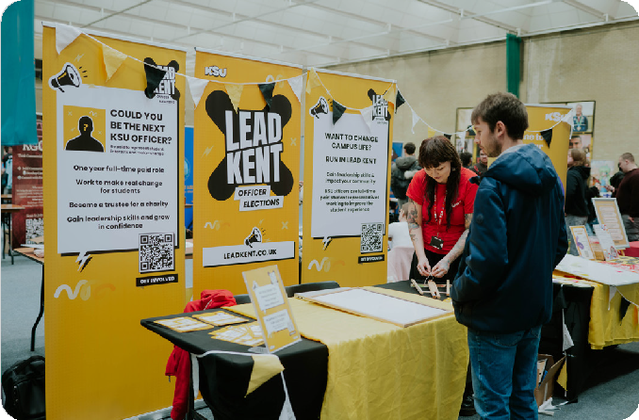
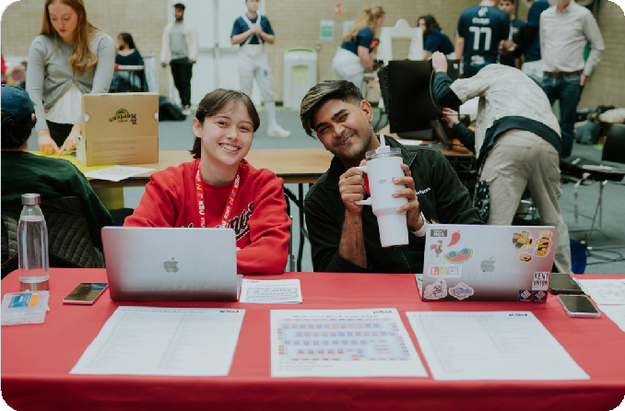

We’re Bold
You’ll be working for an organisation that is innovative and challenges the status quo to stand up for students and ensure they have the best time at university. You’ll get to directly shape what we do and pioneer new areas of work.

We’re Supportive
We’re really flexible as we understand that life isn’t 9-5 and we’ll always look at how we can best adapt to meet your needs; this includes the ability to work remotely.

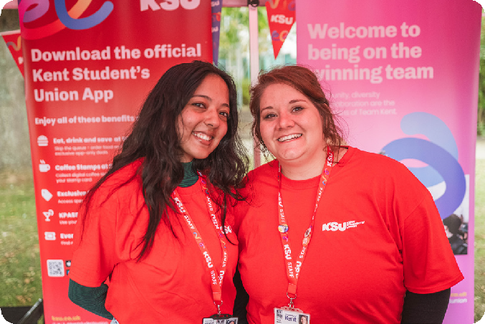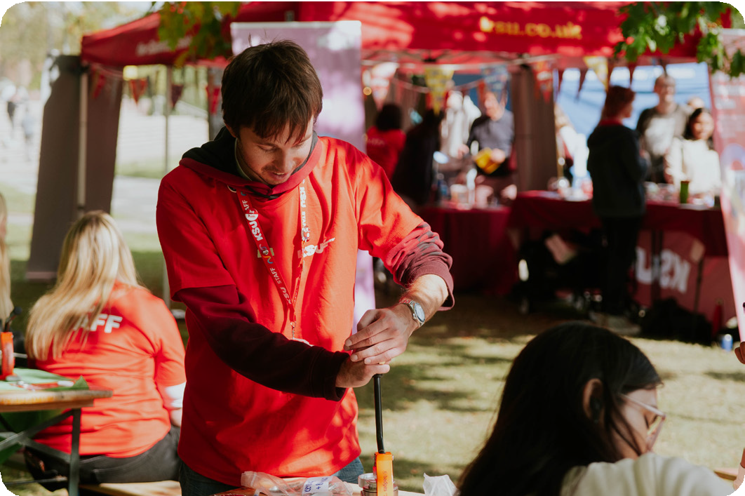

We’re Inclusive
We are an organisation that champions equality and diversity and works to embed this in everything we do. We positively encourage applications from all individuals irrespective of their gender, age, ethnicity, sexuality, religious beliefs, or disability.

It’s Great Fun
We are always working hard to improve the student experience, but we have a great time doing it. You’ll be joining a team of passionate and friendly people and get to be involved in all the incredibly random fun things we do that make Students’ Unions such amazing and unique places to work.

Our Commercial Services
The commercial services through KUTL include catering and licensed trade, retail, business development and the nursery. The total budget across all commercial services is over £9million and the staff team is around 70 career staff and 300 student staff.

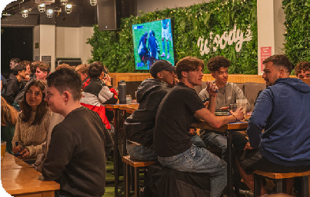
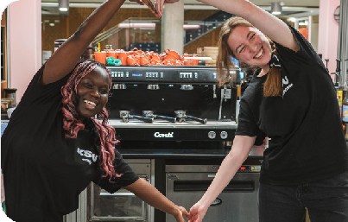

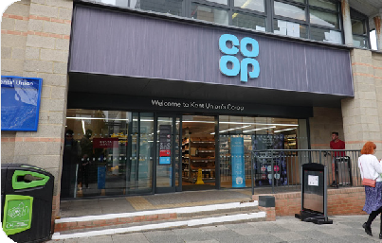
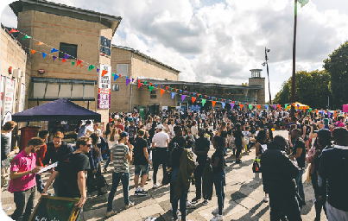
The Venue Nightclub
The Venue is the largest student night club in Canterbury and plays host to a wide range of late-night entertainment from Welcome Week, Summer Balls to regular weekly club nights.
thevenuekent.co.uk
Woody’s
Woody’s has been renovated to an exceptional standard and is a social hub for students to build student communities, providing everyday food and drink for students on campus.
ksu.co.uk/woodys
Campus Coffee
Campus Coffee is a hive of activity and the perfect place for coffee, soft drinks, light snacks and lunch, located in the library.
ksu.co.uk/campus-coffee
Oaks Nursey
Kent Student’s Union operates a 95 capacity children’s nursery. This is a key service to both staff and students, enabling them to study and work.
oaksnurserykent.co.uk/
Retail
Kent Student’s Union was sector leading in the development of retail and is host to two Co-op franchise stores. Collectively these turnover
£5 million and are an essential service to students and staff on campus.
SU Network
SU Network specialises in student market advertising, with deep insight into campus culture. It has grown to support over 25 campuses and many more bookings nationwide.
sunetwork.co.uk/

Where We Work
We have five buildings over the University of Kent campus, from where we deliver services for
students, including our bars, venues a nursery and shops. This post includes hybrid working, with an office in the Mandela Building (University of Kent, Canterbury CT2 7NW), with occasional travel to other campuses.
There are bus links to the campus and the nearest train station is Canterbury West, which is approximately a 20-minute walk. There are also parking spaces available on the purchase of a permit and the campus also has plenty of cycle parking spaces.

When We Work
Kent Student’s Union recognises the importance of helping its employees balance their work and home life and so we have cutting-edge flexible
working policies and many ways in which staff can work flexibly and remotely, based on the nature of the role and in line with business needs.
Any employee can make a request for flexible working. Whilst we cannot guarantee to accommodate a flexible working application, we do guarantee that we will carefully consider any request made.

Equality, Diversity & Inclusion
Kent Student’s Union is committed to the principles of equality of opportunity. A key priority for us is
to improve racial and ethnic diversity amongst our workforce, and as such we particularly welcome applications from racially and ethnically marginalised backgrounds candidates (REMP).

Racially & Ethnically Marginalised Peoples (REMP) Priority Interview Scheme
We recognise that applicants from racially and ethnically marginalised backgrounds may have experienced additional barriers when applying for new roles.
Therefore, if you meet the minimum criteria (at least 80% of the ‘essential’ criteria in the person specification) and are from a REM background, you’ll be guaranteed an interview.
If you are a REM applicant and would like to be considered under our guaranteed interview scheme, you must indicate this by selecting the relevant box on the application form.
If you do not select this box, your application will be considered alongside all other applications. It is important to note that this scheme guarantees an interview for REM applicants who mee the minimum criteria. The selection decision at interview will be based on the most suitable candidate, regardless of background or protected characteristic.

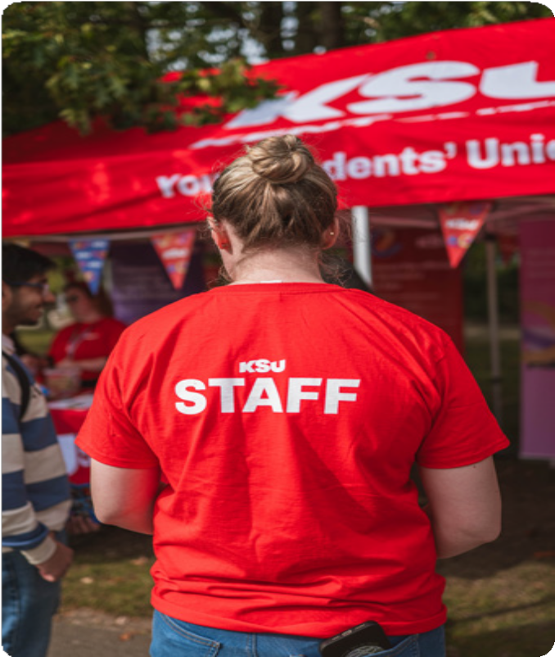
About The Department

Department Name | Kent Union Licensed Trade - KUTL
Description | KUTL is the commercial arm of Kent Student’s Union, which includes Business Development, Retail, Catering and Licensed Trade and Nursery.  We are a vibrant, student-led organisation with a bright future ahead of us. After a challenging few years, we are going from strength to strength with a renewed focus and energy to amplify the voice of our members and ensure they have a fantastic student experience. Our driving force is our new strategy, which sets out our priorities over the next four years.  Students are the reason Kent Union exists. We are there through their university journey. Our amazing staff and volunteers work towards improving their experience, whether it’s helping them with their studies, practicalities of life or to have fun.
What We Do | We are a strong and successful students’ union that delivers a broader range of services than most other UK Students’ Unions. We run student opportunities, events and services that are sector-leading and engage thousands of students every year.  The goals in our strategic plan going forward are to be ‘student led’, ‘here for you’ and ‘a place of opportunities’ for our students. We do this by being an expert on and advocate on behalf of students, campaigning and challenging for a positive and inclusive experience for them and empowering them to make the most of the many opportunities available to them.  Kent Student’s Union is a great place to work. We were re-accredited with Investor in People Gold status in December 2014, and were accredited with Leaders in Diversity in 2013. We were the first students’ union in the UK to achieve Investing in Volunteers status and have been included in the Sunday Times 100 Best Not-For-Profit Organisations to Work For, for 11 years, placed 17th for 2020.

About The Role

Job Title | Team Kent Vensday Mascot
Salary Range | £14.57 per houre (inclusive of Holiday Pay)
Annual Leave | N/A
Reports To | Commerical Events Manager
Place Of Work | The Venue, Woody’s, Various locations on campus
Working Hours | Approx. 2 shifts per week, approx. 6 hours per week.  The post holder will be required to work most Wednesday afternoons and Wednesday nights during term time, plus occasional other evenings, weekends and weekdays.
Pension
Role Purpose | The Team Kent Vensday Mascot is responsible for bringing our horse mascot to life and creating a fun, energetic and memorable presence across Kent Students’ Union events and activities. The primary purpose of the role is to build excitement and a sense of community around Team Kent and Vensday, helping students feel connected to university sport and student nightlife.  The postholder will attend selected BUCS sports fixtures to cheer on Team Kent teams, interact with players and spectators, encourage crowd participation and contribute to a positive match-day atmosphere.  The mascot will also appear at Vensday club nights, engaging with students, dancing on stage and taking part in planned entertainment and promotional activities. They will represent the personality of the Vensday brand and help create distinctive moments that enhance the student experience.  A key element of the role will be participating in promotional and social media content, including Instagram Reels and TikToks. Working alongside the Events and Marketing teams, the postholder will help create engaging content that promotes upcoming fixtures and Vensday events, showcases the student experience and increases awareness of both brands.  The role requires someone who is confident, energetic, reliable and comfortable performing in front of large groups while wearing a full mascot costume. The postholder must represent Kent Students’ Union positively and professionally, follow all health and safety guidance and help create an environment that is welcoming, inclusive and enjoyable for all students.

Duties And Responsibilities

Operational Duties
• Wear and perform in the Team Kent Vensday horse mascot costume at agreed BUCS fixtures, Vensday club nights and occasional promotional activities.
• Create an energetic and positive atmosphere by cheering on Team Kent teams and encouraging appropriate student participation and support.
• Engage warmly and inclusively with students, athletes, spectators and guests while remaining in character.
• Promote Vensday through visible, enthusiastic interaction at fixtures and events, in line with agreed campaign messages and brand guidelines.
• Dance on stage and take part in planned entertainment moments at Vensday, following instructions from the events team, venue management and security.
• Participate in social media content including Instagram Reels and TikToks, contributing engaging and viral content ideas where appropriate.
• Attend agreed shifts punctually, allow time to change into and out of costume, and keep the costume secure, clean and in good condition.
• Follow costume-use guidance, venue rules, safeguarding expectations, risk assessments and health and safety procedures, including taking agreed rest, hydration and cooling breaks.
• Report any costume damage, safety concerns, incidents or inappropriate interaction promptly to the supervising manager.
• Carry out other reasonable mascot and promotional duties consistent with the nature of the role.
People Responsibilities
• Work cooperatively with the events team, student sports clubs, venue staff, security and content creators.
• Represent Kent Students’ Union, Team Kent and Vensday positively, professionally and inclusively at all times.
• Respect personal boundaries and obtain or follow the organiser’s process for consent when interacting closely with students or appearing in content.
• Take direction well, communicate clearly with the supervising manager and support a safe, enjoyable experience for participants and audiences.

Duties And Responsibilities

Financial Responsibilities
• Use the mascot costume and any associated equipment responsibly, minimising avoidable loss or damage.
• This role has no sales or income-handling responsibility unless specifically authorised and trained.
Expected Behaviours
• Student focused – creates welcoming, memorable experiences and responds positively to students from all backgrounds.
• Bold and energetic – performs with confidence, enthusiasm and creativity while staying within agreed boundaries.
• Inclusive and respectful – treats everyone fairly, respects personal space and adapts interactions to the situation.
• Reliable and responsible – arrives on time, follows instructions and takes costume, venue and personal safety seriously.
• Collaborative – works constructively with colleagues, sports clubs, performers, content teams and venue staff.
• Professional – protects the reputation of Kent Students’ Union, Team Kent and Vensday, including when appearing in social media content.

What We’re Looking For

Personal Specification
Essential requirements should be demonstrated before appointment and maintained in post. Desirable elements should be developed and maintained once in post as needed.

Essential, Desirable,Tested at Interview and Application

Qualifications | E | D | I | A
Educated to degree level (or equivalent) |  | X |  | X
A relevant specialist or technical qualification i.e. ITIL |  | X |  | X
Experience | E | D | I | A
Experience engaging positively with students, customers, event audiences or members of the public. | X |  | X | X
Experience in performance, dance, entertainment, events, sport or promotional activity. |  | X | X | X
Experience appearing in or helping to create short-form social media content. |  | X | X | X
Experience working in a busy event, nightlife, hospitality or sports environment. |  | X | X | X
Experience following a briefing and working as part of a team. | X |  | X | X
Knowledge | E | D | I | A
Awareness of Team Kent, university sport and BUCS. |  | X | X | X
Awareness of Vensday and student nightlife in Canterbury. |  | X | X | X
Understanding of appropriate professional boundaries, consent and inclusive audience engagement. | X |  | X | X
Basic awareness of health and safety in crowded event and sports settings. | X |  | X | X
Understanding that activity in costume must follow the direction of the supervising manager, venue management and security. | X |  | X | X

Skills And Ability | E | D | I | A
Confident, outgoing and able to engage an audience enthusiastically while remaining in character. | X |  | X | X
Able to dance, gesture and perform safely in a full mascot costume for agreed periods. | X |  | X | X
Reliable, punctual and able to attend agreed BUCS fixtures and evening Vensday shifts. | X |  | X | X
Able to follow instructions, respond calmly to changing situations and recognise when to seek support. | X |  | X | X
Able to communicate effectively with colleagues before, during and after a performance, including while costume visibility and hearing may be restricted. | X |  | X | X
Values And Behaviours | E | D | I | A
Evidence of a personal commitment to continuing professional development. | X |  | X | X
A team player, who helps others build a successful team, celebrates others’ success and supports others to achieve individual and collective goals and objectives. | X |  | X | X
A commitment to equality of opportunity; someone who builds a culture of inclusivity and diversity. | X |  | X | X
A commitment to working in a democratic and charitable organisation, with the ability to build constructive relationships with people all across the organisation, and externally. | X |  | X | X
Additional requirements | E | D | I | A
Full UK driving licence and willingness to drive company or hired vehicles where required |  | X

How To Apply

Positioned Advertised | 7/8/26
Applications Close | 26/8/26
Shortlisting | 27/8/26
Interviews | 8/9/26
To apply, please submit your application through our recruitment portal at ksu.co.uk/careers.

Please ensure that you pay particular attention in your application to detailing how your experience meets the requirements of the person specification and why you are interested in the position.
If you have any further questions about the role or the application process, please contact NAME, JOB TITLE by emailing EMAIL

Completed applications must be received by 26/8/26 at 23.59pm




ksu.co.uk

